**PH-6021 2-socket** cache isolated **RS-485** Hub **(HUB)** data sheet

1. Product overview

The PH-6021 two-way cache-isolated RS485 hub is a communication device that supports two RS485 master devices and one or more RS485 slave devices. The circuit is designed with 15KV ESD protection and 5KA lightning surge protection devices, which can effectively isolate the harm caused by lightning strikes and static electricity to the equipment. Each of the three communication interfaces has a communication indicator, which can visually see the status of each communication port. Transparency between master and slave interfaces

The data transmission, communication format and baud rate can be set by software.

This product is suitable for automatic control system, monitoring system, alarm, access control system, IC card charging, meter reading, one card

Integrated RS485 communication system for passing, parking lot charging, etc.

Second, functional characteristics

• Power input DC9-36V with overcurrent and reverse polarity protection

•Supports two RS485 master devices communicating with one or more RS485 slave devices

•Support for module ID settings (only the Modbus-RTU protocol is restricted).

•The three port baud rate and communication format can be set independently

•Signal interface with static electricity, lightning strike, surge protection

• Communication and power are fully isolated between master and slave interfaces

•Super anti-interference, high-speed MCU and high-speed optocoupler are used, and the baud rate can reach up to 115200

•The slave communication port supports up to 32 nodes

3. Specification parameters

|  |  |  |
| --- | --- | --- |
| project | parameter | remark |
| Input voltage | DC9-36V | Exceeding 36V may be damaged |
| Static power consumption | 0.6W |  |
| Communication method | RS-485 |  |
| Communication format | Standard communication format check digits are optional |  |
| Communication protocol | Transparent transport has no protocol restrictions | A question-and-answer format applies |
| baud rate | 2400- 115200 Optional |  |

官网 <http://www.ahphll.com> 1

咨询热线：0557-2777889

|  |  |  |
| --- | --- | --- |
| ESD protection | 15KV |  |
| Inrush current protection | 5KA |  |
| Working environment | -40 °C 到 85 °C |  |

4. Interface and function description

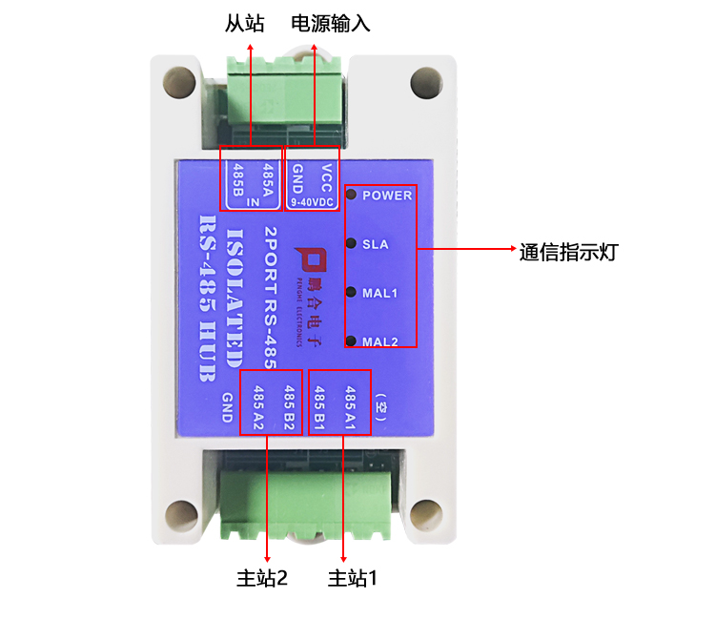

**4.1** Power interface

DC9-36V power supply input, supply current greater than or equal to 0.5A can be. The voltage must not exceed 36V, otherwise the circuit will be damaged.

The interface is marked "VCC" to the positive pole of the power supply, and the "GND" is connected to the negative terminal of the power supply. The power connector has reverse polarity protection, and the reverse connection will not

Damage.

**4.2** Communication interface

The device has a total of 3 sets of communication interfaces, MAI and MA2 are connected to RS485 master devices, and IN are connected to RS485 slave devices. Slave

It can be 1 or more units, and up to 32 slaves can be connected. "A" and "B" port 485 of device 485

The ground port of "B" and "GND" ground.

Official website <http://www.ahphll.com> 2

Hotline: 0557-2777889

**4.3.** Indicator light

1. Power indicator: The red POWER indicator flashes after powering on .

2. Communication indicator: Each of the 3 communication ports (SLA, MAI, MA2) has a communication indicator, which indicates when receiving data

The light flashes and the MA1 indicator flashes when entering parameter setting mode.

|  |  |  |  |
| --- | --- | --- | --- |
| Light | function | color | Status and significance |
| POWER | Status LED | red | Render breathing light: The module is working properly |
| SLA | Slave communication indicator | yellow | Blinking: The slave has data communication |
| MA1 | Master 1 communication indicator | green | 1. Flashing in normal mode: Master 1 has data communication |
| 2. Uniform flashing between 1 second interval in setting mode: means entering parameter setting mode |
| 3. Flashing at 100ms interval, factory reset |
| MA2 | Master 2 communication indicator | green | Blinking: Master 2 has data communication |

**4.4.** Typical application wiring method

1. The connection method of communication between two RS485 masters and one RS485 slave

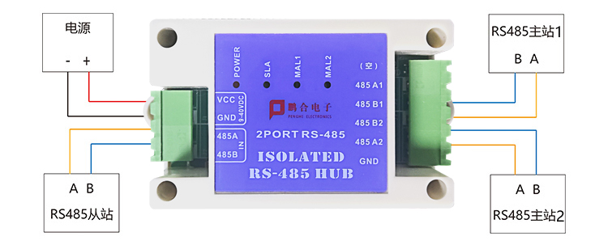

2. Connection method for communication between two RS485 masters and multiple RS485 slaves

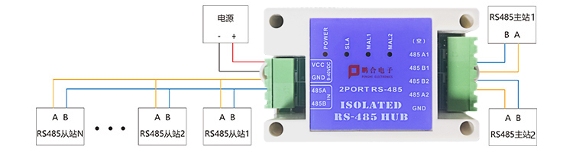

**4.5.** Dimensional drawing

官网 <http://www.ahphll.com> 3

咨询热线：0557-2777889

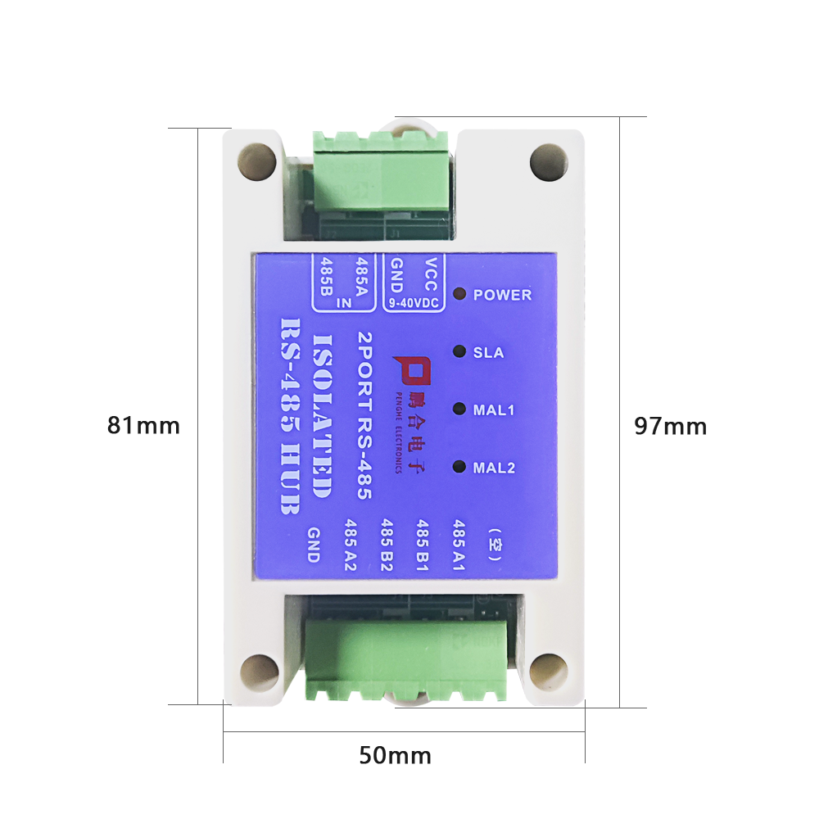

As shown in the figure above, the length, width and height of the module are 97*50*31mm

5. Parameter configuration description

Connect the wiring method shown below, open the setting software on the computer, find the corresponding serial port number and select, the baud rate, data bit, stop bit, and check digit should be selected to be consistent with the hub MAL1 port. Hub factory default baud rate 9600, 8 data bits, 1 stop bit, no validation.

Official website <http://www.ahphll.com> 4

Hotline: 0557-2777889

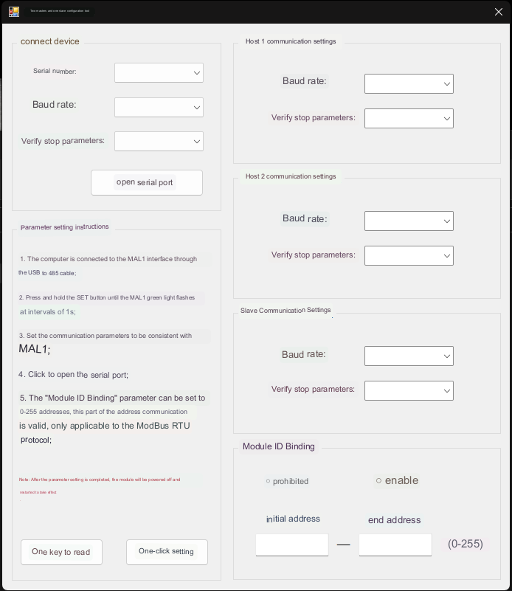

After selecting the serial port parameters, click the "Open Serial Port" button

Press SW1 button 3s or so, click the "one-click read" button on the software to enter the configuration mode.

Set the parameters in the software options as needed and click the "One-click Setup" button, click "OK" after the "Module Configuration Successful" dialog box pops up, power on and restart the module, and the parameters take effect.

**5.1** Software Description

1. The communication parameters of the three channels can be set independently through the configuration software.

2. You can set a continuous address from the "start address" to the "end address", and the data frames within the address range can communicate through the module. Note End address is greater than or equal to the start address. "Enable is within the address range can be transmitted

Official website <http://www.ahphll.com> 5

Hotline: 0557-2777889

Input, forbidden is that the address range cannot be transmitted.

3. If you only need to set 1 address, the "start address" and "end address" are the same.

4. The "Start Address" and "End Address" can be set to be the same as the slave module address connected to the SLA port.

5. This function is currently only available for the Modbus-RTU protocol.

6. **RS485** communication wiring specifications and precautions

**6.1**, **RS485** bus wiring specification

1. The standard RS485 bus wiring method is commonly known as the hand-in-hand connection method, and the star connection method should be avoided as much as possible.

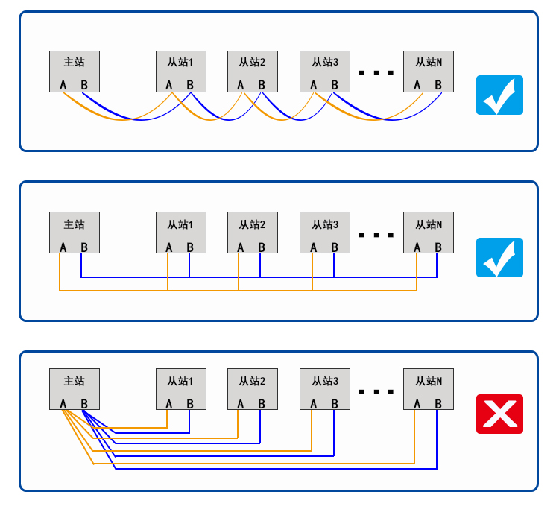

2. Use 2-core shielded twisted pair, the wire diameter thickness can refer to the "Wire Selection Recommended Table", the bus length is not more than 1200 meters, the bus attachment equipment is not more than 32, and the branch wire length is not more than 10 Rice.

3. The communication line should be as far away as possible from the source of interference, and the communication line should go to the weak well, and cannot be parallel with the strong current or radio frequency signal line

If parallel lines must be routed, the distance should not be greater than 0.5 meters.

4. All devices on the same network segment must have a unified signal ground to avoid common-mode interference.

**6.2** , **RS485** wiring precautions

1 . The maximum communication distance of the 485 communication standard is 1200 meters, but in practical applications, this distance cannot be reached, and the higher the baud rate

The shorter the signal distance, the general communication distance of more than 500 meters requires the addition of 485 signal repeaters.

2. When there are many devices attached to the bus, in order to avoid signal reflection, it should be connected in parallel between the communication port AB of one device at the farthest distance

A 120 ohm matched resistor.

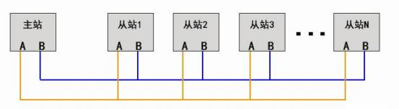

3. The shielded wire of the communication line should be connected to the ground wire, which is the earth and not the negative pole of the power supply.

Wire selection recommendation table

|  |  |
| --- | --- |
| Wiring distance | wire rod |
| Less than 200 meters | 2*0.5 two-core shielded twisted pair |
| 200-500 meters | 2*0.75 two-core shielded twisted pair |
| Greater than 500 meters | 2*1.0 two-core shielded twisted pair |

Troubleshooting

1. The circuit board is not powered on, the indicator light is not on, check whether the power cord is connected correctly, whether the positive and negative poles are reversed, and measure with a multimeter

If the supply voltage is correct, the red indicator on the board will be displayed as a breathing light after troubleshooting.

2. Unable to communicate, check whether the communication port 485 line is reversed, each communication channel corresponds to an indicator light, receive the correct data indicator flashing, if there is no flashing, check whether the communication format and baud rate of the hub are consistent with the master and slave

If you are not sure, you can reset the parameters to restore the default values.